Circuit Diagrams

This document contains the circuit diagrams for the circuits used on the Arduino to connect with the various components. The arrows to the numbers represent the pin assignments on the board. Some pins are written to be a +5V source or a GND in the code. The resistors are 10k Ohm.

Switch Diagram

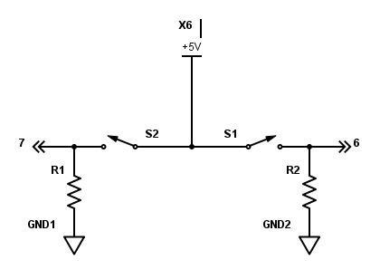

Servo Diagram

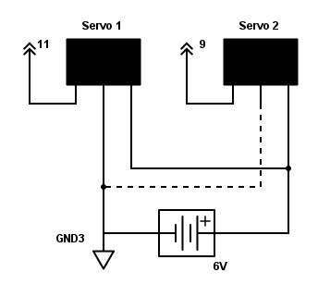

Speaker Diagram

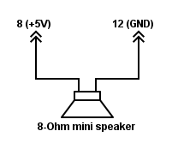

IR Sensor Diagram

